# Using Eclipse, Practice It, & Submitting Files

Throughout this course, you will be writing code and submitting it to your instructor. In today’s lesson, we will review the procedure to:

* open Eclipse
* set up a workspace
* create a file
* save a file and eject your USB safely

Sometimes you will complete coding projects online, via Practice It. Practice It is a web app that allows you to practice coding in Java online. In this lesson, you will:

* create a Practice It account
* learn how to log in
* learn how to submit an answer

Eclipse Procedure Overview

Each of the following steps is explained in detail on the following pages. As you repeat the steps, you will become more familiar with them, and so we’ve offered this quick reference guide so that you can check the steps quickly and easily in the future.

*Plug In Procedure Un-Plug Procedure*

1. Turn on your computer 1. Save all
2. Log into student account 2. Exit Eclipse
3. Insert USB drive 3. Safe-eject USB drive
4. Launch Eclipse using the thumbnail 4. Remove USB drive
5. Set Workspace to F:\
6. Enter Workbench
7. Create new Java Project
8. Create new Java Class

Plug In Procedure

Turn on & Login

1. Turn on the computer and wait for it to power up.
2. If prompted for login, your teacher will give you your username and password. Record your username and password here for safekeeping:

username: password:

Insert USB Drive

1. Insert USB drive
2. Some Windows messages might appear—ignore them.

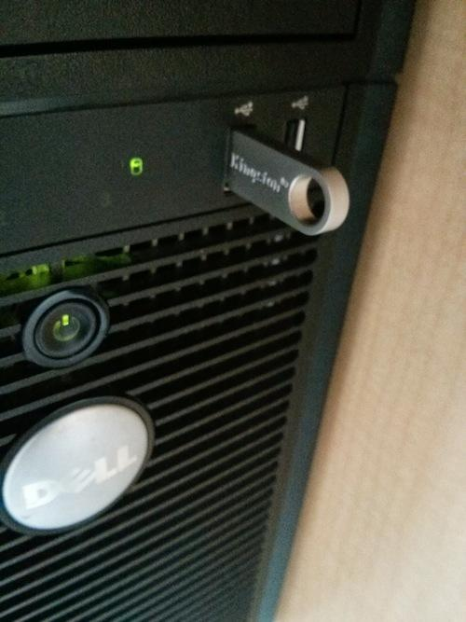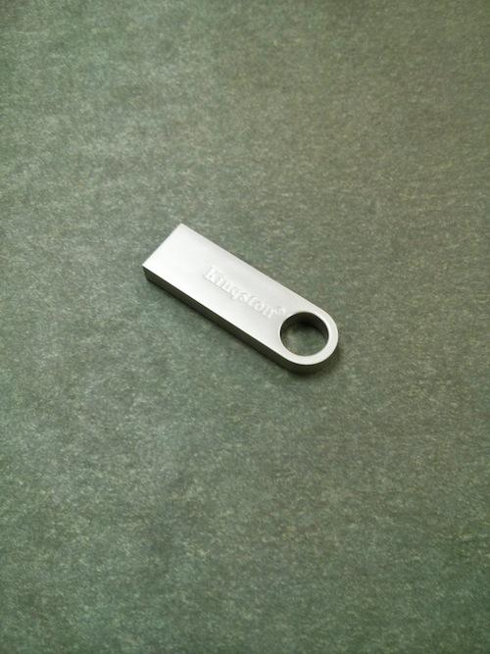

Start Eclipse & Workspace

1. Double-click on the Eclipse Icon on the desktop
2. Type F:\ as the Workspace location. The \ character can be found near the return key on the upper right section of your keyboard.

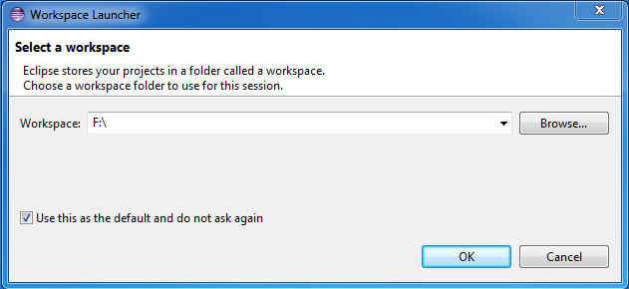

Click “Use this as the default” and then click on OK.

Enter Workbench

1. Double-click on the Eclipse Icon on the desktop

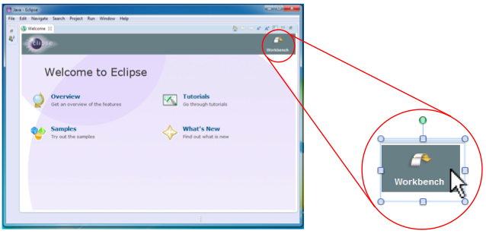

Create New Project

1. Create a new Project with File > New > Java Project.

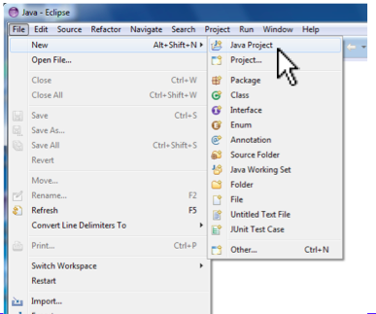

1. Fill in the project name, then click on Finish.
   1. *The Project Name will usually be given to you by your teacher; in general you should name your project something descriptive (instead of “Project One”) to help you find it later.*

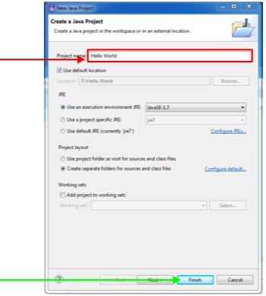

Create New Java Class

1. Right-click your Project and select New > Class.

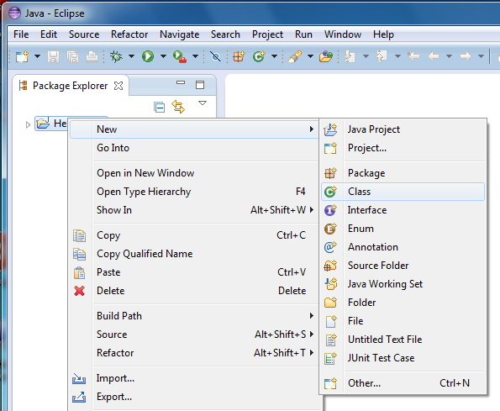

Right click here

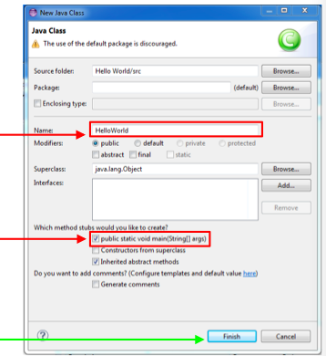

1. Enter Class name (only letters

a-z and A-Z).

1. Click to create a main() method
2. Click Finish

Running Your Program

1. Type the following line of code after // TODO Auto-generated method stub

System.out.println (“Hello, world.”);

1. Save file with Ctrl-S
2. Click on the Run Icon
3. Look for output in the Console Window.

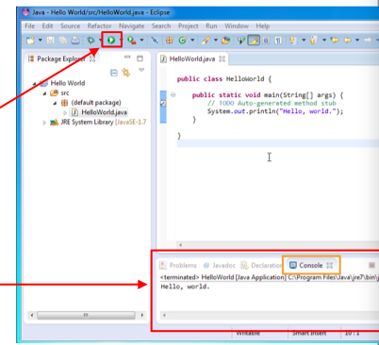



Un-Plug Procedure

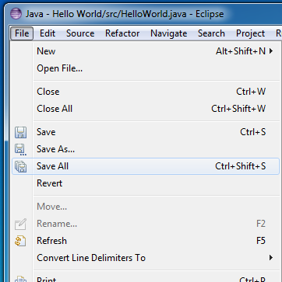

Save All

1. Click on File > Save All to

save all edited files.

*This text might be greyed-out*

*and not-clickable if all files*

*have already been saved.*

Exit Eclipse

1. Select File > Exit

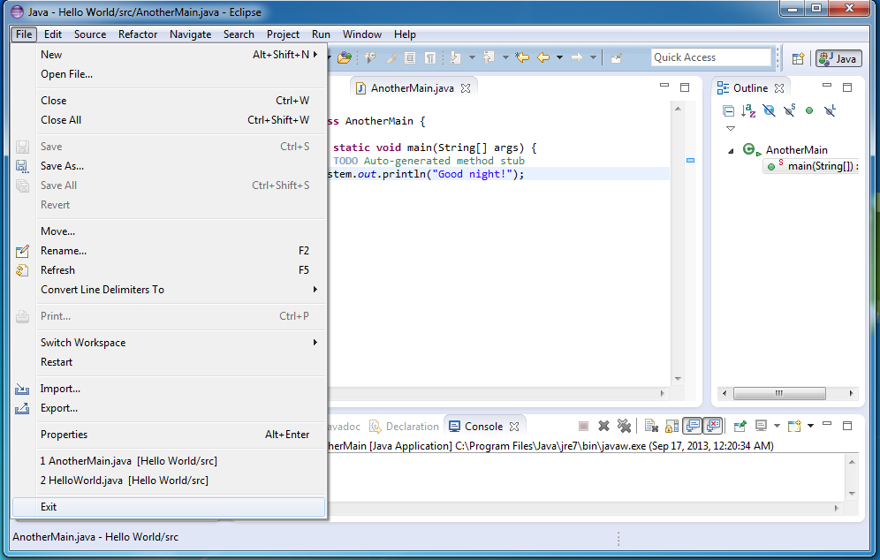

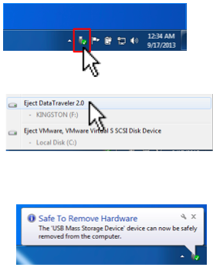Safe-Eject USB Drive

1. Click on the Devices icon in the

lower-right corner of the screen.

1. Select Eject Data Traveler
2. Wait for Safe to Remove Hardware

message.

Remove USB Drive

6. Remove the USB Drive from the Computer. Don’t forget to take it with you, and be sure to bring it back to class each day!



Practice-It

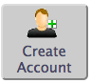Create an Account

1. Navigate to practiceit.cs.washington.edu
2. Click on Create an Account
3. Enter the name of your school. If your school name does not come up, add your school

name by clicking on the Add School button.

1. Enter in your information. Be sure to choose a Username that will be easy for you to

remember. Record your Username and password here for your records:

Username:

Password:

1. Type in the Captcha code, then click Create Account.

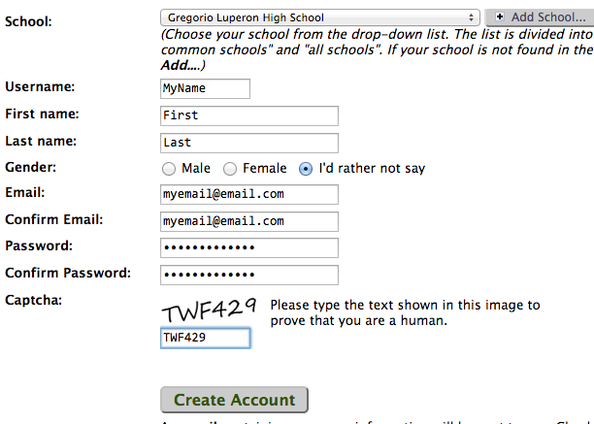

Verify Your Account

1. A message will pop up, asking you to verify your account by checking your email.

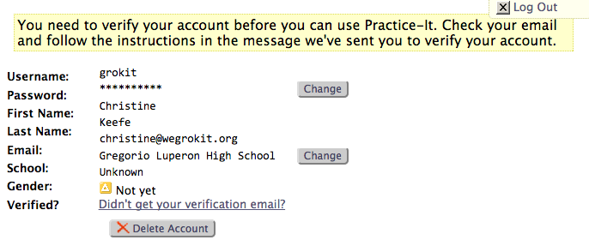

1. Find the email from Practice it, and follow the link on your email to verify the account.

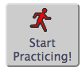Complete a Sample Problem

1. On the main page, click on the button Start Practicing!
2. Your teacher will tell you which edition of Building Java Programs you are using in your class. For your records, write down which edition to click on here:

Building Java Programs, Edition #:

1. Click on the correct edition, then click on the Chapter 1 link.

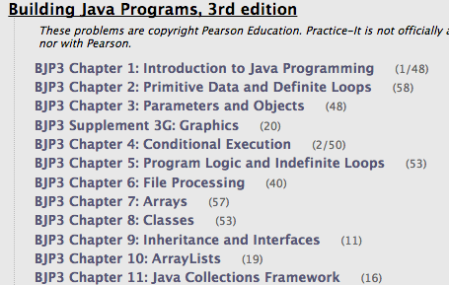

Screen Shot 2015-03-31 at 12

1. Now click on the first problem binaryNumbers.

Select an answer and click the submit button.

1. If you got the answer correct, go to the next question by clicking on the button at the upper-right most corner of the window.
2. If you would like to turn off the sound effects, scroll to the bottom of the window and uncheck the Sound F/X button.

